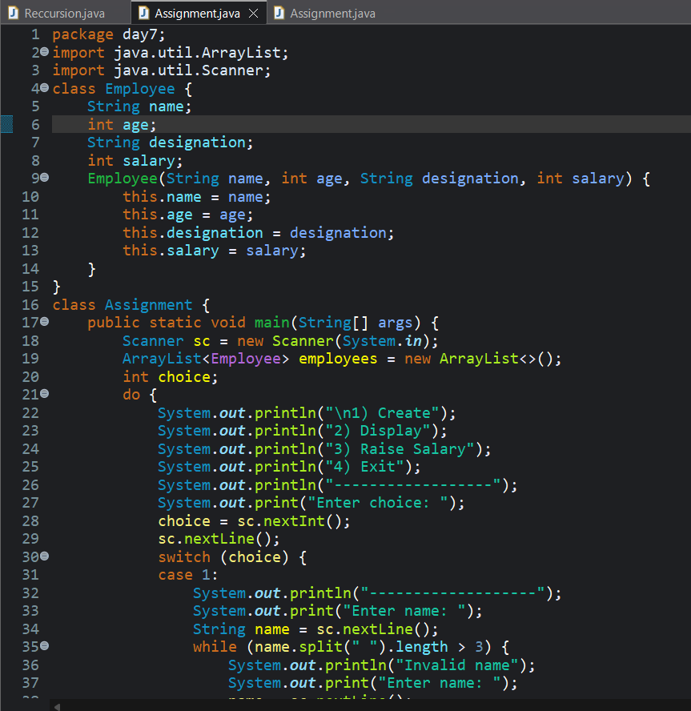
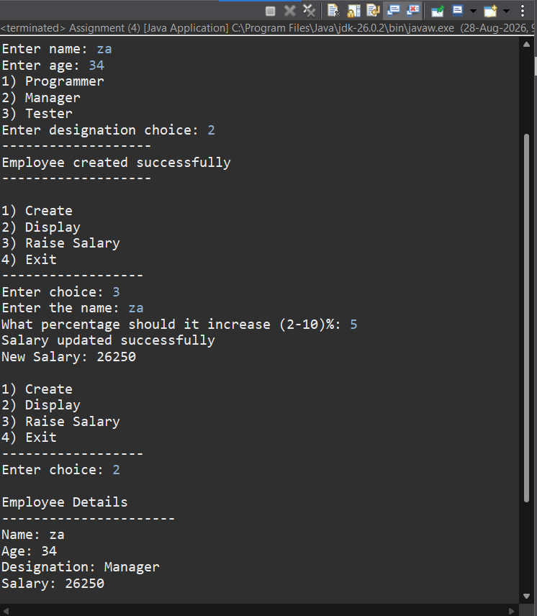
Employee Management System – Report
The Employee Management System is a menu-driven Java program developed to manage employee details efficiently. The program uses classes, objects, constructors, ArrayList, Scanner, loops, conditional statements, and switch-case. It provides four options: Create, Display, Raise Salary, and Exit. While creating an employee, the program accepts the employee’s name, age, and designation and assigns a starting salary based on the selected designation. It also validates the employee’s age, name, and designation. The Display option shows the details of all employees stored in the ArrayList. The Raise Salary option allows the user to search for an employee by name and increase their salary by a percentage between 2% and 10%. Overall, this program demonstrates the practical use of Java object-oriented programming and collection concepts to build a simple employee management system.

